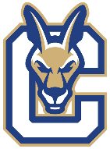
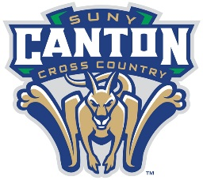
2024 Men’s Cross Country Roster

NAME YR. HOMETOWN / HIGH SCHOOL
Mohamed Bah So. Bronx, NY / Bronx School for Law, Government & Justice
Wyatt Beers Fr. Mount Upton, NY / Unatego
Jonathan Bentivegna So. Mahopac, NY / Mahopac
Justin Bormann Fr. Malone, NY / Franklin Academy
Logan Bradley Fr. Norfolk, NY / Norwood-Norfolk
Derick Chavez So. Wolcott, NY / North Rose-Wolcott
Derek Hillicoss Fr. Voorheesville, NY / Clayton A. Bouton
Kristian Johnson So. Lake George, NY / Lake George
Gage Perry So. Mineville, NY / Moriah
Matthew Pietryka Jr. Whitehall, NY / Granville
Daniel Ryhal Sr. Addison, NY / Addison
Wilfried Feukouo Ulrich Sr. Yaounde, Cameroon / International

Coaching Staff
John Kennedy Head Men's & Women’s Cross Country Coach
Katie Kennedy Assistant Men’s & Women’s Cross Country Coach

