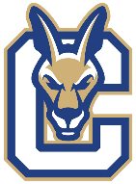
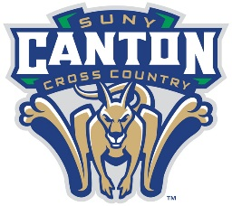
2024 Women’s Cross Country Roster

NAME YR. HOMETOWN / HIGH SCHOOL
Megan Cowles Jr. Hyde Park, NY / F.D. Roosevelt
Summer Foster So. Nunda, NY / Dansville
Jenna Leshkevich Sr. Redwood, NY / Alexandria
Sophia McKiernan So. Moriah, NY / Moriah
Sydney Pelerin Fr. Ticonderoga, NY / Ticonderoga
Mayella Rubin Sr. Elmont, NY / Elmont
Madison Ruby Sr. South Glens Falls, NY / South Glens Falls
Tyler Schwedler Fr. Theresa, NY / Indian River

Coaching Staff
John Kennedy Head Men’s and Women’s Cross Country Coach
Katie Kennedy Assistant Men’s and Women’s Cross Country Coach

